School of Computer Science and Artificial Intelligence

Lab Assignment # 1

Name of Student : R. SHIVA SAI REDDY
Enrollment No. : 2303A51542
Batch No. : 22

Task 1: AI-Generated Logic Without Modularization (Factorial without
Functions)

Prompt:-
write a python code to calculate the factorial of a number without using functions.

Code:-
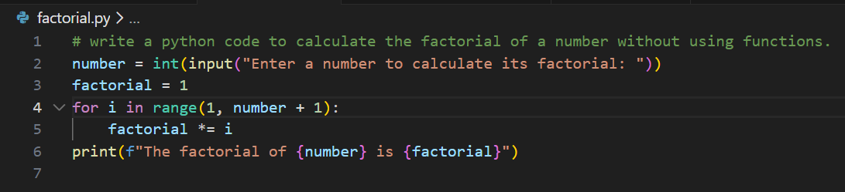

Output:-
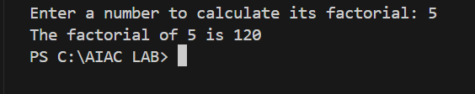

Justification:-

Think of this code as a straight-line solution it solves the problem quickly and directly without any extra packaging. It’s perfect for a one-off task where you just need the answer right away, though it isn't built to be shared or reused easily in bigger projects.

Task 2: AI Code Optimization & Cleanup (Improving Efficiency)

Prompt:-
Optimize the above code by removing unnecessary variables, simplifying the loop, and improving readability.

Code:-
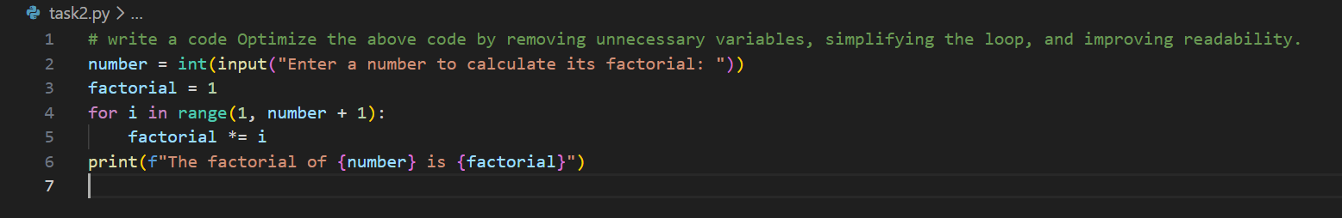

Output:-
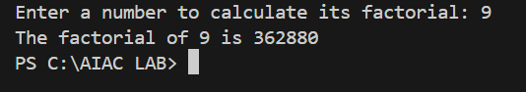

Justification:-

This version streamlines the logic by stripping away clutter and focusing on the most direct way to get the result. It’s essentially a cleaner, more grown-up version of the previous code that’s easier for a teammate to read and maintain.

Task 3: Modular Design Using AI Assistance (Factorial with Functions)

Prompt:-
write a python code on factorial with function

Code:-
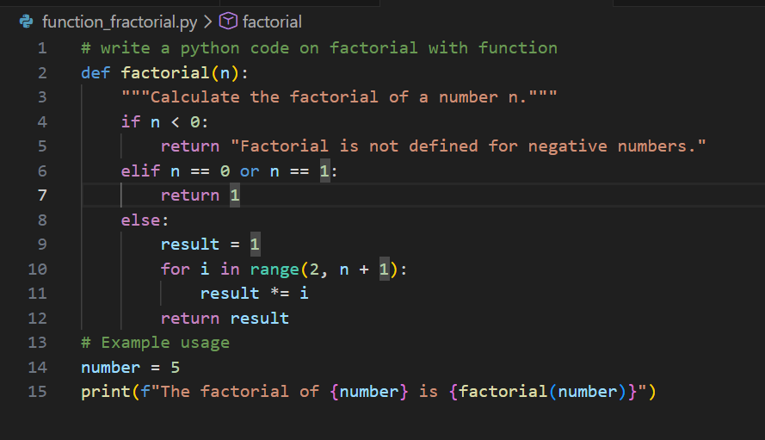

Output:-
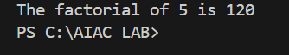

Justification:-

This version wraps the logic into a tidy, reusable "tool" called a function, making the code much more professional and organized. By separating the calculation from the display, you can now use this same logic anywhere else in your project without having to rewrite it from scratch.

Task 4: Comparative Analysis – Procedural vs Modular AI Code (With vs
Without Functions)

Prompt:-
Write a program that compares an AI-written script that’s all in one block and a version that uses clear, well-named functions, explaining which is better for
understanding, reuse, debugging, big projects, and avoiding over-reliance on AI, and show it in a small table.

Code:-
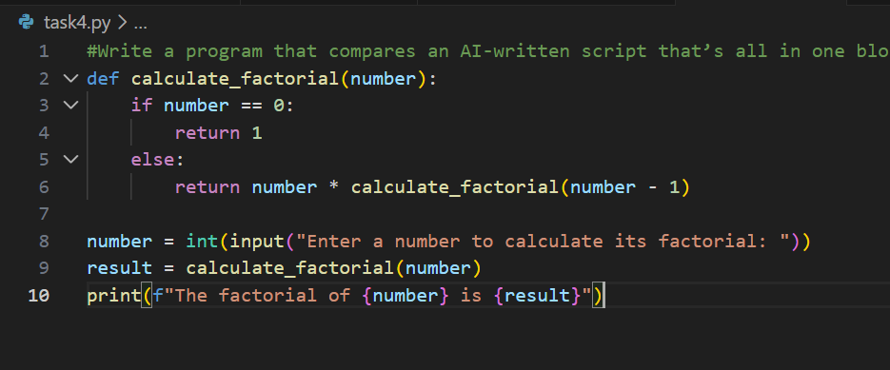

Output:-
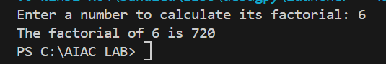

Justification:-

This version uses a recursive function to elegantly handle the logic, making the code much easier to read and test compared to a single long script. It’s built for modern teamwork, where clear, reusable "blocks" of code are essential for building and debugging large, professional projects.

Task 5: AI-Generated Iterative vs Recursive Thinking

Prompt:-
write a program on create iterative version logic vs recursive version logic of factorial and explain their flow and compare readability, stack usage, performance, and when recursion should be avoided.

Code:-
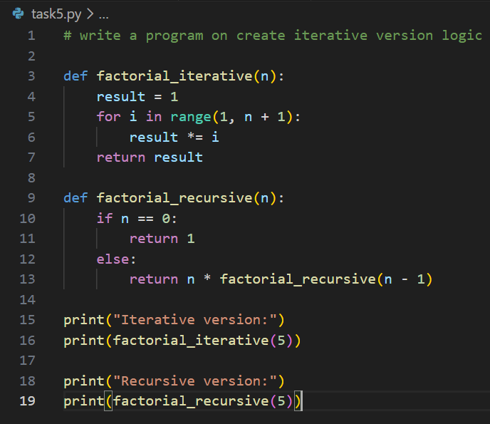

Output:-
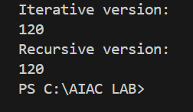

Justification:-

This comparison highlights the two main ways computers "think": the iterative version uses a simple, efficient loop for direct calculation, while the recursive version breaks the problem down into smaller, repeated steps. While recursion looks more elegant and mathematical, the iterative approach is often safer for very large numbers because it doesn't risk overloading the computer's memory stack.

